**<StarBug Cafeteria Management System>**

**Software Development Plan (Small Project)**

**Version <1.0>**

**Revision History**

| **Date** | **Version** | **Description** | **Author** |
| --- | --- | --- | --- |
| 26/10/2023 | 1.0 | Initial draft of the documentation | Intech.Co |
|  |  |  |  |
|  |  |  |  |
|  |  |  |  |

**Table of Contents**

**1.** **Introduction 4**

*1.1* *Purpose 4*

*1.2* *Scope 4*

*1.3* *Overview 4*

**2.** **Project Overview 4**

*2.1* *Project Purpose, Scope, and Objectives 4*

*2.2* *Assumptions and Constraints 4*

*2.3* *Project Deliverables 5*

**3.** **Project Organization 5**

*3.1* *Organizational Structure 5*

*3.2* *Roles and Responsibilities 6*

**4.** **Management Process 6**

*4.1* *Project Estimates 6*

*4.2* *Project Plan 6*

4.2.1 Phase Plan 6

4.2.2 Releases 7

4.2.3 Project Schedule 8

4.2.4 Iteration Objectives 11

4.2.5 Project Resourcing 12

*4.3* *Project Monitoring and Control 12*

4.3.1 Requirements Management 12

4.3.2 Reporting and Measurement 12

4.3.3 Risk Management 13

4.3.4 Configuration Management 14

**Software Development Plan (Small Project)**

# **Introduction**

The purpose of this document is to provide an overview of the StarBug cafeteria management system. The plan includes the following: purpose, scope, definitions, acronyms, abbreviations, references, and an overview of this specific Software Development Plan for StarBug cafeteria management system.

## **Purpose**

* **Project team members** use it to understand what they need to do, when they need to do it, and what other activities they are dependent upon.

The purpose of this Software Development Plan is to collect and gather all available necessary information in order to control the project. The plan describes the main approach to the development effort of the software and is the highest-level plan created and used by managers to drive and direct the developmental effort.

The following people use the Software Development Plan:

* The **project manager** uses it to plan out the project schedule and resource needs, and to track and follow progress against the upcoming schedule.
* **Project team members** use it to understand what they need to do, when they need to do it, and what other activities they are dependent upon.

## **Scope**

This *Software Development Plan* describes the overall plan to be used by the StarBug Cafeteria Management project, including deployment of the product. The details of the individual iterations will be described in the Iteration Plans.  
The plans as outlined in this document are based upon the product requirements as defined in the *Vision Document* provided.

## **Overview**

This *Software Development Plan* for StarBug Cafeteria Management System contains the following information:

Project Overview — provides a description of the project's purpose, scope, and objectives.  It also defines clearly the deliverables that the project is expected to deliver.

Project Organization — describes the organizational structure of the project team and its various member.

# **Project Overview**

## **Project Purpose, Scope, and Objectives**

**Purpose:**

* This project will enhance the quality of services of the cafeteria in which they can let the customer feel free in ordering coffee, tea or cake themselves without asking the waiter. It also helps the salers to manage their menu easily.

**Scope:**

* This project aims to reach everyone especially for people who would like to drink daily and for those who have a liking for coffee but don’t have free time to go for it. This also aims to increase the customer for those cafeteria who use it, more profit comes to the business.

**Objectives:**

* When more cafeterias use this software, they will attract more customers by the simplicity of how they present the menu and by the convenience of the service. This project will enhance its key goal to make the complicated stuff become simple and easy to use.

## **Assumptions and Constraints**

* Project has 5 members
* Budget of project: There is no budget for this project
* This project has a fixed schedule about 5 sprints (10 weeks)

## **Project Deliverables**

The deliverables of the project could be:

* Software Development Plan
* Vision Document
* Weekly Report
* Use-case specification
* Software architecture document
* UI prototype
* Source Code / Prototype
* Test Case, Test plan, Test script
* UI Mockup Design
* Project’s Database Schema

# **Project Organization**

## **Organizational Structure**

* Our team decided the structure to work smoothly, such as one Scrum Master as well as Team Leader and each tech stack also has a particular Team Leader to deal tasks, deadlines, instruct technological frameworks, and track their teammates. For instance:
* Scrum Master:
  + Front-end Team: Team Leader, Teammates (developers, tester, and designers)
  + Back-end Team: Team Leader, Teammates (developers, and tester)
  + Project Managers
  + Business Analyst
* Scrum Master manages the whole team, collects ideas, and works closely with Business Analyst and two Team Leaders.
* Our lecturers and also project reviewers:
* Mr. Nguyễn Văn Vũ
* Mr. Trần Duy Hoàng
* Mr. Trương Phước Lộc
* Mr. Ngô Ngọc Đăng Khoa

## **Roles and Responsibilities**

| **Person** | **Role** |
| --- | --- |
| Lê Hoàng Sang: Scrum Master, Software Architect, Front-end Team Leader, Tester | Responsible for ensuring workflow of the whole team, Front-end team, and collecting requirements from the Business Analyst. As a Front-end Team Leader, writing UI components, dealing tasks and meeting with Back-end Team Leader to build a complete architect and Restful API for the system. Testing the team’s components. |
| Trần Minh Quang: Back-end Team Leader, Software Architect, Trần Minh Quang, Tester | Responsible for ensuring workflow of the whole team, Back-end team, and collecting requirements from the Business Analyst. As a Back-end Team Leader, dealing tasks and meeting with Back-end Team Leader to build a complete architect and Restful API for the system. Testing the team’s logical functions, and database queries. |
| Nguyễn Quốc Huy: Front-end Developer, Project Owner, Tester | Responsible for implementing UI components, managing tasks and deadlines on the management platform (Trello). Testing written components. |
| Phù Thành Nhân: Project Owner, Back-end Developer, Tester | Responsible for implementing server side’s logic, managing tasks and deadlines on the management platform (Trello). Testing written functions. |
| Vũ Đình Chương: Front-end Developer, Designer, Tester | Responsible for implementing UI components, designing layout and complete UI. Testing written components. |

# **Management Process**

## **Project Estimates**

## **Project Plan**

### *Phase Plan*

| **Phase** | **Sprint** | **Time** | **Brief description** |
| --- | --- | --- | --- |
| Inception  (23/10 - 2/11) | Sprint 1 | 23/10/23 - 2/11/23 | Define product features, software development plan, business model |
| Elaboration  (3/11 - 30/11) | Sprint 2 | 3/11/23 - 16/11/23 | Design UI for user site, database, use-case, … |
| Sprint 3 | 17/11/23 - 30/11/23 | Design UI for admin site and Implement UI for user site Define Software Architecture, class Diagram |
| Construction  (1/12 - 23/12) | Sprint 4 | 1/12/23 - 14/12/23 | Implement website function, finishing UI for both user and admin Providing UI prototype |
| Sprint 5 | 15/12/23 - 23/12/23 | Test plan, test case Preparing for presentation |

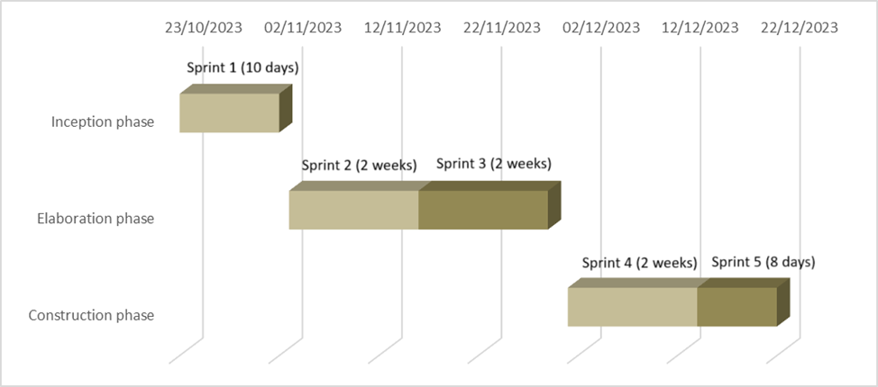

### *Releases*

**Expected demo**

* **When:** After sprint 3 - 1/12/23
* **User-site features the Release should achieve at least**
  + Login/Sign up
  + Show up product
  + Comment/ Rating Product
  + Search product
  + Making order

**Release**

* **When:** After sprint 4 - 15/12/23
* **The Release should achieve all the featured requirements**

### *Project Schedule*

| **Phase** | **Sprint** | **Task** | **Time** | **Assignment** |
| --- | --- | --- | --- | --- |
| **Inception** | Sprint 1 | Specify the features, planning the idea | 23/10/23 - 23/10/23 | All members |
| Design the UI/UX for home page | 27/10/23 - 31/10/23 | Chương |
| Writing Software Development Plan, Vision Document | 27/10/23 - 31/10/23 | All members |
| Design the API/ Database for product, slider, Promotions (home content) | 27/10/23 - 30/10/23 | Quang, Sang |
| **Elaboration** | Sprint 2 | Code UI for home page | 3/11/23 - 7/11/23 | Chương, Huy, Sang |
| Create Database and API for product, slider, Promotions | 3/11/23 - 7/11/23 | Nhân, Quang |
| Draw use-case model and use-case specification, write use-case document | 8/11/23 - 10/11/2002 | Nhân, Quang |
| Revised Project Plan, Complete Vision Document | 8/11/23 - 10/11/2002 | Huy, Sang |
| Design about page and login form | 8/11/23 - 10/11/2002 | Chương |
| Design database and API for user account | 8/11/23 - 10/11/2002 | Quang |
| Design database and API for product page, detail product page | 12/11/23 - 15/11/23 | Quang |
| Design UI/UX for product page, detail product page, payment form | 12/11/23 - 15/11/23 | Chương |
| Code UI/UX about page and login form | 13/11/23 - 15/11/23 | Huy, Sang |
| Create database for user account | 13/11/23 - 15/11/23 | Nhân |
| Sprint 3 | Code UI/UX for product page, detail product page, payment form | 17/11/23 - 22/11/23 | Huy, Sang |
| Design UI/UX for admin site (edit product, edit staff account) | 17/11/23 - 23/11/23 | Chương |
| build database and API for product page, detail product page | 17/11/23 - 20/11/23 | Nhân |
| define class diagram | 17/11/23 - 22/11/23 | Quang |
| Revise use-case specification | 21/11/23 - 22/11/23 | Nhân |
| define software architect document (SAD) | 24/11/23 - 29/11/23 | Quang, Nhân, Sang, Huy |
| Reviewing user site, fix error (if have) | 27/11/23 - 29/11/23 | Chương |
| **Construction** | Sprint 4 | Design UI/UX Admin site (tracking order, visualizing data) | 1/12/23 - 7/12/23 | Chương |
| Code UI/UX for Admin site (edit product, edit staff account) | 1/12/23 - 7/12/23 | Huy, Sang |
| Design API for specifying the nearest branch for the order + calculating fee ship | 1/12/23 - 7/12/23 | Quang |
| Design API for visualizing data + tracking order | 1/12/23 - 7/12/23 | Nhân |
| Implement API for visualizing data + tracking order | 8/12/23 - 11/12/23 | Nhân |
| Implement API for specifying the nearest branch for the order + calculating fee ship | 8/12/23 - 11/12/23 | Quang |
| Revise SAD | 12/12/23 - 13/12/23 | Quang, Nhân |
| Code UI/UX Admin site (tracking order, visualizing data) | 7/12/23 - 13/12/23 | Huy, Sang |
| write UI prototype | 7/12/23 - 13/12/23 | Chương |
| Sprint 5 | Test case, test plan | 15/12/23 - 19/12/23 | Quang, Sang |
| Prepare presentation | 20/12/23 - 22/12/23 | Nhân, Huy |
| Review whole website | 15/12/23 - 22/12/23 | Chương |
|  |  |  |  |  |
|  |  |  |  |  |

### **Gantt chart**

* Inception phase

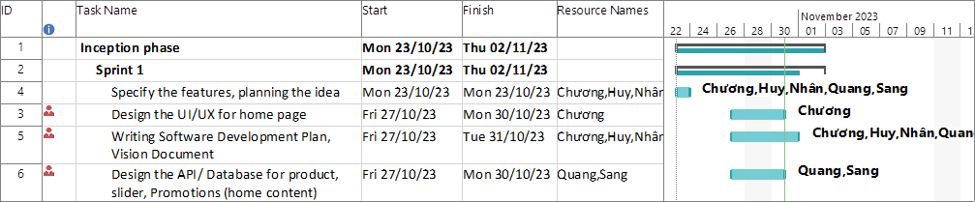

* Elaboration phase

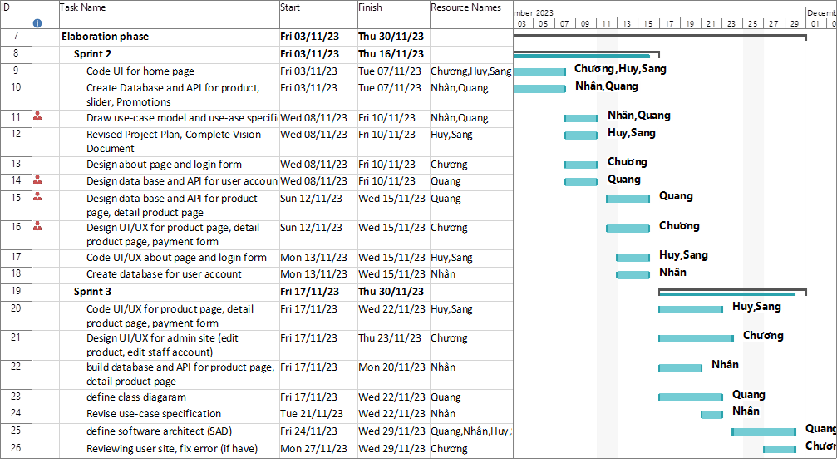

* Construction phase

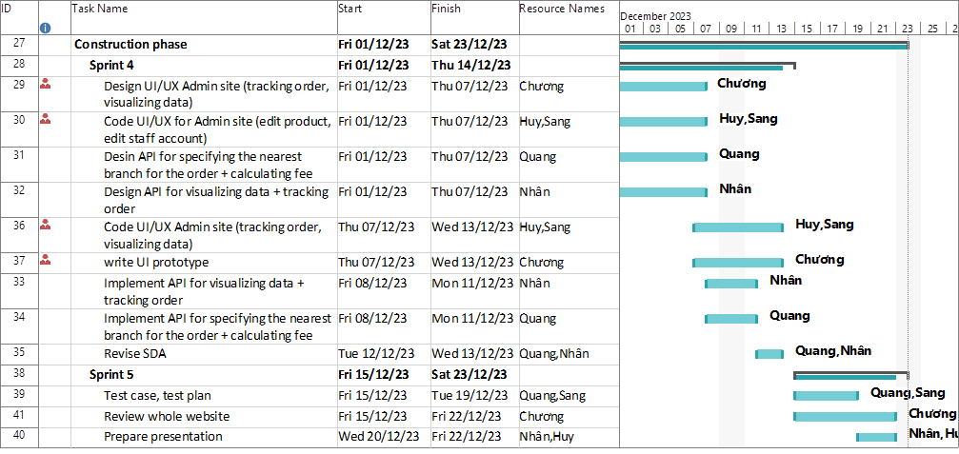

### Iteration Objectives

Sprint 1:

* Software development plan (SDP)
* Vision Document
* Features Requirement

Sprint 2:

* Specifying the design for user site

Sprint 3:

* Implement all user-site page
* Specifying the design for admin site

Sprint 4:

* Admin site page
* All functionality of project

Sprint 5:

* Passing all test case, test plan
* Presentation

### *Project Resourcing*

Special skills for each phase

* Inception
  + Software management
  + Software process (RUP, Scrum)
* Elaboration
  + Use-case model, use-case specification
  + UML
  + Class Diagram
  + Software Architecture
* Construction
  + UI prototype
  + Test case, test plan

Skills will be used throughout the software life cycle

* Front-end skills
  + Figma
  + React, React hook, Redux
  + Tailwind
* Back-end skills
  + Database (mongoose)
  + Nodejs (expressjs)
  + Restful API
* Other skill
  + Content writer
  + SEO

## **Project Monitoring and Control**

### *Requirements Management*

Our team holds weekly meetings at 9 PM every Tuesday and Friday. During the meetings, members will discuss tasks done and progress made the preceding week. At the same time, we talk about challenges and difficulties each member is confronted with and together find a way to solve them. Then we will discuss plans for next week.

### *Reporting and Measurement*

Updated cost and schedule estimates, and metrics summary reports, will be generated at the end of each iteration.

The Minimal Set of Metrics, as described in the RUP Guidelines: Metrics, will be gathered on a weekly basis. These include:

Earned value for completed tasks. This is used to re-estimate the schedule and budget for the remainder of the project, and/or to identify need for scope changes.

Total defects open and closed – shown as a trend graph. This is used to help estimate the effort remaining to correct defects.

Acceptance test cases passing – shown as a trend graph. This is used to demonstrate progress to stakeholders.

In addition, overall costs will be monitored against the project budget.

### *Risk Management*

Risks will be identified in the Inception Phase using the steps identified in the RUP for Small Projects activity “Identify and Assess Risks”. Project risk is evaluated at least once per iteration and documented in this table. The risks of the greatest magnitude are listed first in the table.

| **Risk Ranking (High, Medium, Low)** | **Risk Description and Impact** | **Mitigation Strategy and/or Contingency Plan** |
| --- | --- | --- |
| High | Risk Description: Work progress does not match the plan.  Impact :If work progress is not guaranteed so schedules delay, increased costs, stakeholder dissatisfaction, reputation damage. | All members support each other in work.  If a member has problems, must say it so people can help.  Everyone needs to work with the spirit of putting the team's goals first. |
| High | Risk Description: Server Downtime.  Impact :If the website's server goes down, customers won't be able to access the site, leading to loss of sales and customer trust. | Regularly monitor server health and performance.  Invest in a reliable hosting provider.  Implement automated failover mechanisms to quickly switch to backup servers in case of downtime. |
| Medium | Risk Description: Payment Processing Failure.  Impact: If the payment gateway experiences issues, customers may be unable to make purchases, leading to revenue loss and frustrated customers. | Use multiple payment gateways to provide redundancy.  Regularly test payment processing to identify and resolve issues proactively.  Offer alternative payment methods (e.g., VNPAY, MoMo, ZaloPay) as a contingency. |
| Medium | Risk Description: Supplier Disruptions.  Impact: If coffee suppliers experience disruptions in their operations, it can lead to delays in product availability and customer dissatisfaction. | Diversify your supplier base to reduce reliance on a single supplier.  Maintain buffer stock to mitigate short-term supply interruptions.  Establish clear communication channels with suppliers to receive early warnings of potential disruptions. |
| Low | Risk Description: Mobile Responsiveness Issues  Impact: If the website isn't properly optimized for mobile devices, it may lead to a subpar user experience and lost sales from mobile users. | Regularly test the website's mobile responsiveness on various devices and browsers.  Invest in responsive web design and user interface testing.  Offer a mobile app as an alternative for mobile users. |

### *Configuration Management*

Appropriate tools will be selected which provide a database of Change Requests and a controlled versioned repository of project artifacts.

All source code, test scripts, and data files are included in baselines. Documentation related to the source code is also included in the baseline, such as design documentation. All customer deliverable artifacts are included in the final baseline of the iteration, including executables.